Essential SQL command

Keywords are uppercased.

# 1CREATE DATABASE statement:

CREATE DATABASE Journey;

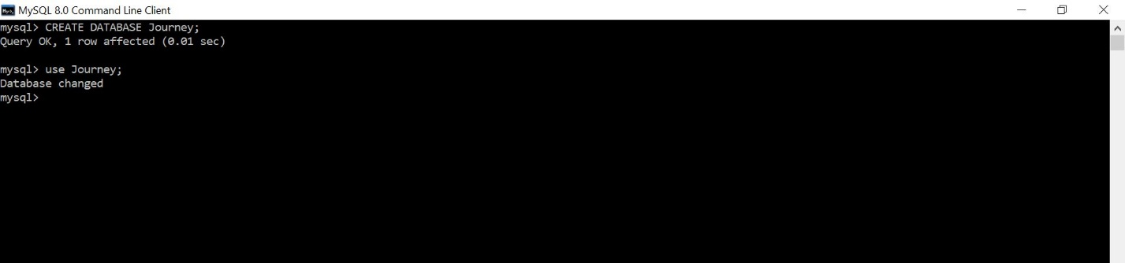

After creating the database, use “use” command to use the database just created.

use journey;

# 2.CREATE TABLE statement:

**Examples 1:**

CREATE TABLE journey(

journeyid varchar(40),

containerid varchar(40),

origin varchar(40),

destination varchar(40)

);

**Examples 2:**

CREATE TABLE container_status(

containerid varchar(40),

temperature float(6),

air_pressure float(6)

);

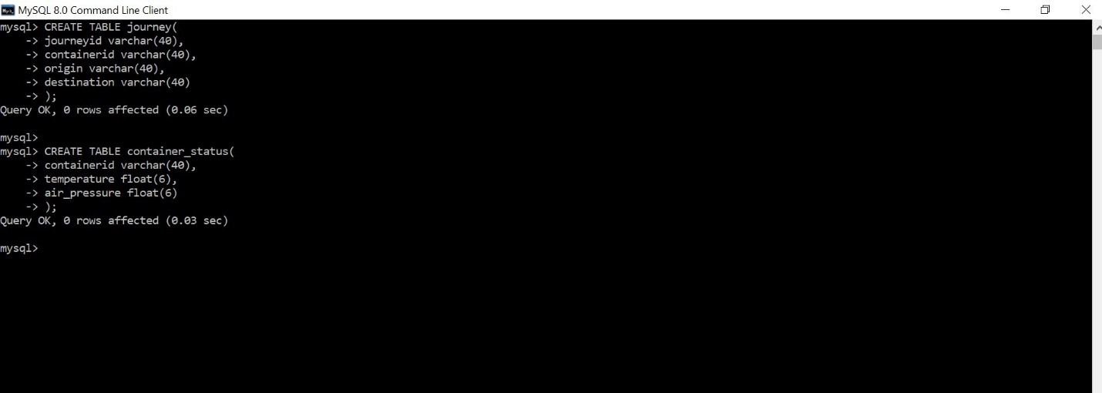

# 3. INSERT INTO Statement:

Insert records into a table.

INSERT INTO journey (journeyid, containerid,origin, destination) VALUES (“1”,”1”,”US”,”China”);

INSERT INTO journey (journeyid, containerid, origin ,destination) VALUES (“2”,”2”,”China”,”Germeny”);

INSERT INTO container_status VALUES(1,25.5,1000.2);

INSERT INTO container_status VALUES(2,28,120.2);

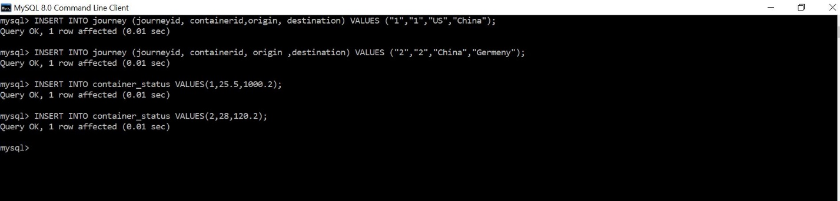

4.SELECT FROM statement

SELECT * FROM journey;

Asterisk “*” means everything. So this statement selects every record in the journey table

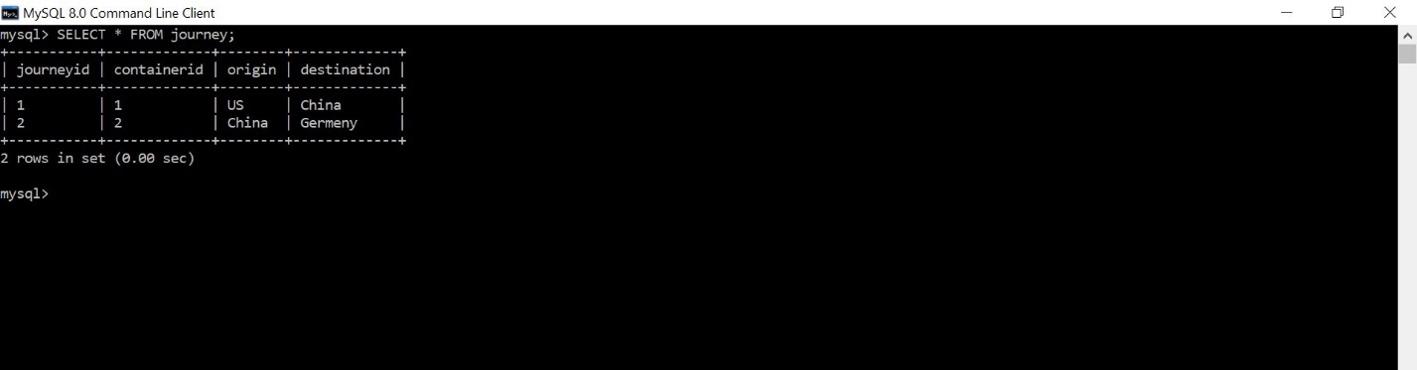

# 5.SELECT FROM with conditional keyword WHERE:

SELECT journey.journeyid,journey.destination FROM journey WHERE journey.origin="US";

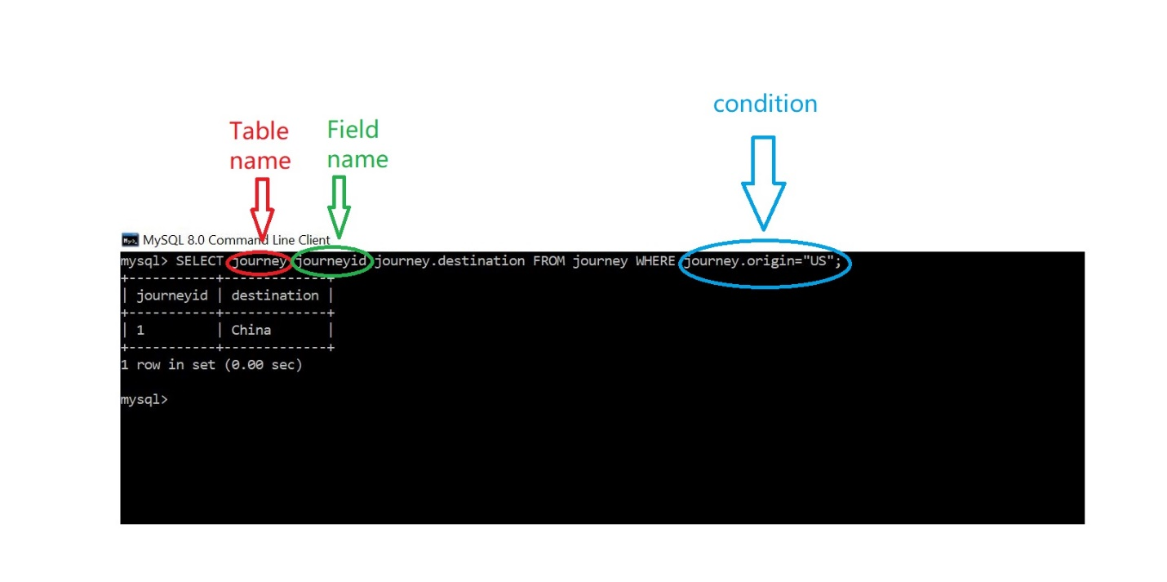

# 6. INNER JOIN statement:

Used to connecting tables that have relations. The following statement selects the records from “journey” table and “container_status” table that has matching “containerid”;

SELECT * FROM journey INNER JOIN container_status ON journey.containerid=container_status.containerid;

